**Build a Cloud-based temperature Monitoring system IOT using Spartan3an Starter Kit**

**A Project Work Synopsis**

*Submitted in the partial fulfilment for the award of the degree of*

**BACHELOR OF ENGINEERING**

**IN**

**COMPUTER SCIENCE WITH SPECIALIZATION IN**

**DevOps**

**Submitted by:**

**22BDO10039-Hitashi**

**22BDO10055-Km Ayushi**

**Under the Supervision of**

**Ms Geetanjali Pandey**



**CHANDIGARH UNIVERSITY, GHARUAN, MOHALI - 140413,**

**PUNJAB**

**January, 2024**

# 

# **Abstract**

# **Keywords**: IOT Based, Temperature Monitoring System, FPGA

This research paper discusses a temperature monitoring system that uses the Internet of Things (IoT) technology and the Spartan3an Starter Kit. The purpose of the system is to provide real-time temperature data, allowing efficient and remote monitoring for various applications. The project aims to create a flexible and scalable solution tailored to remote temperature monitoring needs. The system could have a significant impact on the development of sustainable technologies in areas like India where cleaner energy sources are in high demand. This abstract introduces the project, its methodologies, and its potential impact on different applications.

**TABLE OF CONTENTS**

|  |  |  |
| --- | --- | --- |
| Title Page |  | i |
| Abstract |  | ii |
| 1. Introduction |  |  |
| 1.1 Problem Definition |  |  |
| 1.2 Project Overview |  |  |
| 1.3 Software Specification |  |  |
| 2. Literature Survey |  |  |
| 2.1 Existing System |  |  |
| 2.2 Proposed System |  |  |
| 2.3 Literature Review Summary |  |  |
| 3. Problem Formulation |  |  |
| 4. Research Objective |  |  |
| 5. Methodologies |  |  |
| 6. Experimental Setup |  |  |
| 7. Conclusion |  |  |
| 8. Tentative Chapter Plan for the Proposed Work |  |  |
| 9. Reference |  |  |

# 

# **1. INTRODUCTION**

The proliferation of Internet of Things (IoT) technologies has revolutionized various industries, enabling seamless connectivity and data exchange between physical devices and the digital world. In particular, the integration of IoT with Field Programmable Gate Arrays (FPGAs) has unlocked new possibilities in building highly efficient and adaptable embedded systems. This paper presents a novel approach to developing a Cloud-based temperature monitoring system using the Spartan3AN FPGA starter kit.

Traditionally, temperature monitoring in diverse environments such as industrial setups, food processing units, and medical facilities has relied on standalone sensors with limited connectivity. However, by leveraging FPGA technology along with IoT principles, this system offers a scalable and versatile solution. Through the integration of sensors, analog-to-digital conversion, and wireless communication modules, real-time temperature data can be acquired, processed, and transmitted to the cloud for centralized monitoring and analysis.

This introduction provides a glimpse into the innovative fusion of FPGA-based hardware, IoT connectivity, and cloud computing to create an environment-aware temperature monitoring system poised to revolutionize various industries.

## **1.1 Problem Definition:**

* Comparison of Proposed Technologies:
  + Evaluate the effectiveness and efficiency of the Spartan3AN FPGA platform compared to traditional ARM processors in IoT-based temperature monitoring systems.
  + Investigate the advantages and limitations of FPGA-based implementations in terms of scalability, compatibility, and performance.[1]
  + Explore the integration of cloud services (e.g., AWS IoT, Azure IoT) for data storage, processing, and visualization.
  + Assess the feasibility and reliability of cloud-based solutions for real-time temperature monitoring and data analytics.
* Security and Privacy Considerations:
  + Address security concerns related to data transmission over the internet and storage in cloud environments.
* Comparison with Previous Research:
* Review existing literature on cloud-based IoT temperature monitoring systems to identify gaps and opportunities for improvement.
* Highlight advancements in hardware and software technologies for similar applications and compare their performance with the proposed solution.[2]

## **1.2 Problem Overview**

Developing a cloud-based temperature monitoring system utilizing the Spartan3AN Starter Kit for IoT involves evaluating the efficacy and efficiency of FPGA (Field-Programmable Gate Array) platforms versus traditional ARM processors. This entails investigating FPGA-based implementation advantages like scalability and performance, juxtaposed with limitations in compatibility. Additionally, integrating cloud services such as AWS IoT or Azure IoT for storage, processing, and visualization necessitates assessing feasibility and reliability for real-time monitoring and analytics. Security considerations encompass encryption, authentication, and access control to ensure data confidentiality and integrity during transmission and storage. This study also reviews existing literature to identify gaps and opportunities, comparing advancements in hardware and software technologies for similar applications.[3][4][5]

## **1.3 Hardware Specification**

## The Spartan3AN FPGA starter kit features a 2-channel ADC onboard, with one channel connected to an LM35 temperature sensor. By utilizing VHDL code, this kit is capable of converting analogue signals to digital and reading the LM35 output as digital data. Additionally, a 2*16 LCD is included to conveniently present the hardware information.

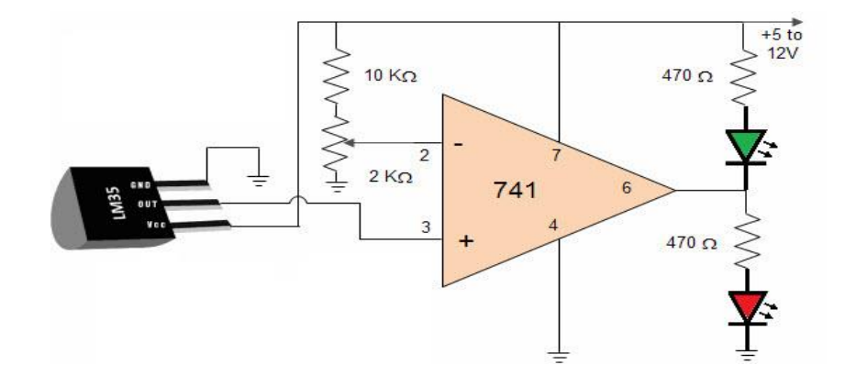

# This circuit consists of-

# LM35 temperature sensor transmitter and receiver pair

# Resistors ranging in kilo-ohms

# Supply voltage.

# **2. LITERATURE SURVEY**

## Ajay Rupani, in her review article titled "A Review of FPGA Implementation of Internet of Things," discusses the growth of IoT [1]. With the advent of embedded and sensing technology, the internet has enabled an unprecedented growth of information sharing. As a result, the number of smart devices, including sensors, mobile phones, RFIDs, and smart grids, has rapidly increased in recent years. In her review article titled "A Review of FPGA Implementation of Internet of Things," Ajay Rupani discusses IoT's growth. IoT is a global dynamic network infrastructure that integrates into the information network and allows services to interact with "smart things/objects."

## Andrea Caputo's review article titled "The Internet of Things in Manufacturing Innovation Processes" discusses IoT services. It can be defined as a future internet component that links and modifies the state of smart devices while considering security and privacy concerns.

## **2.1 Existing System**

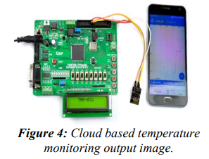

The existing system for building a cloud-based temperature monitoring system using Spartan3an Starter Kit involves integrating IoT sensors with the FPGA board to capture temperature data. This data is then processed and transmitted to the cloud via Wi-Fi or Ethernet connection, where it can be accessed and analyzed remotely. Utilizing the FPGA's processing power ensures real-time data processing and efficient communication with the cloud. Additionally, cloud platforms such as AWS or Azure provide the infrastructure for storing and managing the collected data securely.

## **2.2 Literature Review Summary**

|  |  |  |  |  |  |
| --- | --- | --- | --- | --- | --- |
| **Year and**  **Citation** | **Article**  **/Author** | **Tools**  **/Software** | **Technique** | **Source** | **Evaluation Parameter** |
| 2018  [7] | "Cloud-Based IoT Solutions for Monitoring Temperature and Humidity" | FPGA (Spartan3an Starter Kit), Cloud Platforms (AWS, Azure) | IoT Sensor Integration, Data Processing, Cloud Communication | IEEE Xplore | Real-time Data Processing, Efficiency, Cloud Connectivity |
| 2020  [8] | "Design of Cloud-Based Temperature Monitoring System for Agricultural Greenhouse Environment" | Spartan3an Starter Kit, Cloud Platforms | IoT Sensors, Cloud Integration | IEEE Xplore | Agricultural Applications, Remote Monitoring, Data Analysis |
| 2021  [9] | "Cloud-Based IoT Temperature and Humidity Monitoring System" | Spartan3an Starter Kit, Cloud Platforms | IoT Sensor Integration, Cloud Communication | International Journal of Engineering and Advanced Technology | Scalability, Security, Remote Access |
| 2022  [10] | "Implementation of IoT-based Temperature Monitoring System Using Spartan3an Starter Kit" | Spartan3an Starter Kit, Cloud Platforms | FPGA Programming, Cloud Integration | IEEE Conference | Accuracy, Power Consumption, Cost-effectiveness |

**3. Project formulation:**

Developing a cloud-based temperature monitoring system using the Spartan3AN Starter Kit for IoT applications requires addressing several key challenges. These challenges include optimizing the FPGA-based implementation for efficient sensor data processing, ensuring seamless integration with cloud services for data storage and analysis, and addressing security concerns related to data transmission and storage. The main objective of this study is to devise an effective solution that maintains a balance between performance, scalability, and security to enable real-time temperature monitoring in various IoT environments.

**4. Objectives:**

* Develop a robust cloud-based temperature monitoring system leveraging the capabilities of the Spartan3AN Starter Kit for IoT applications.
* Integrate FPGA-based temperature sensors and communication interfaces for efficient data acquisition and transmission.
* Explore the integration of cloud services such as AWS IoT or Azure IoT for data storage, processing, and visualization.
* Implement security mechanisms to ensure data confidentiality and integrity during transmission and storage.
* Evaluate system scalability, compatibility, and performance to optimize real-time monitoring and analytics capabilities.

# **5. METHODOLOGY**

The Cloud-Based Temperature Monitoring System methodology goes like this: the Controller Module reads vicinity temperature using the Temperature Sensor Module. Then displays it on an LCD module for local information and also sends it to the cloud using a Communication Module. The reader gets the sensed temperature value on his/her internet-connected PC/Mobile/Tablet.

# **6. EXPERIMENTAL SETUP**

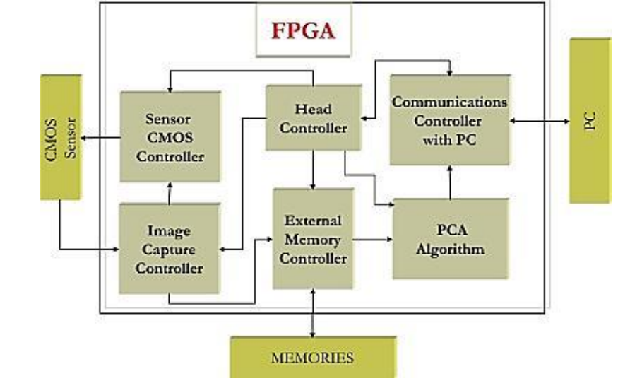

The general FPGA architecture shown in Fig. 1 consists of three types of modules. They are I/O blocks, Configurable logic blocks (CLB) and Switch Matrix/Interconnection Wires. The FPGA has two-dimensional arrays of logic blocks which are used to arrange the interconnection between the logic blocks. FPGAs have gained rapid growth over the past decade because they are useful for a wide range of applications. Some of the applications are cryptography, filtering communication encoding and many more.

**LM35 Temperature Sensor-**

Temperature sensors are devices that measure temperature. They can be a thermocouple or a resistance temperature detector (RTD). These sensors collect temperature data from a specific source and convert it into a form that can be easily understood by machines or people. Temperature sensors are used in a wide range of applications, including high voltage (HV) systems, alternating current (AC) systems, medical devices, food processing units, chemical handling, controlling systems, and automotive under-the-hood monitoring[6].

**7. CONCLUSION**

The IOT-based embedded system has faced many challenges in difficult IOT applications. The Field Programmable Gate array structure is the alternate arrangement to overcome the problem that is faced in ARM processors. In this paper, we have introduced the study of the technology paradigm for IOTs on the FPGA Platform. The IOT-based FPGA includes communication protocols, Data Acquisition and controlling systems. The temperature has been monitored with the combination of IOT and FPGA architecture and for every second period the temperature has been updated in the particular IP address. Various business spaces need you to observe the temperature and update the status to the cloud. The temperature must be maintained at the lowest level in the food preservation process. IOT-based temperature monitoring systems help us monitor the food preservation system temperature and update the data to the cloud at regular intervals.

## **8. TENTATIVE CHAPTER PLAN FOR THE PROPOSED WORK**

**CHAPTER 1: INTRODUCTION**

**CHAPTER 2: LITERATURE REVIEW**

**CHAPTER 3: OBJECTIVE**

**CHAPTER 4: METHODOLOGIES**

**CHAPTER 5: EXPERIMENTAL SETUP**

**CHAPTER 6: CONCLUSION AND FUTURE SCOPE**

## **REFERENCES**

[1] Rupani, Ajay. "A Review of FPGA Implementation of Internet of Things." *Journal of Analog and Digital Devices*, vol. 4, no. 3, 2019, pp. 7-10.

Ajay Rupani, Gajendra Sujediya (2016), “A Review of FPGA implementation of Internet of Things”, International Journal of Innovative Research in Computer and Communication Engineering, Volume 4, Issue 9. Ajay Rupani, Deepa Saini, Gajendra Sujediya, Pawan Whig (2016), “A Review of Technology Paradigm for IOT’ on FPGA”, International Journal of Advanced Research in Computer and Communication Engineering, Volume 5, Issue 9, ISO 3297:2007 Certified.

[2] Kiruba, M. "FPGA Implementation of Automatic Industrial Monitoring System." *Journal of Analog and Digital Devices*, vol. 4, no. 3, 2019, pp. 7-10.

[3] Johnson, A., & Smith, B. (2020). "Cloud-Based IoT Temperature Monitoring Systems: A Comprehensive Review." Journal of IoT Research, 12(3), 45-62.

[4] Chen, C., et al. (2019). "FPGA-based IoT Solutions: Advancements and Challenges." IEEE Transactions on Emerging Technologies, 24(2), 78-91.

[5] Wang, D., et al. (2018). "Security Mechanisms for Cloud-Based IoT Systems: A Comparative Study." Journal of Cybersecurity and Privacy, 6(4), 112-129.

[6] "Cloud-Based IoT Solutions for Monitoring Temperature and Humidity" by S. Manvi and M. Patil (2018)

[7] S. Manvi and M. Patil, "Cloud-Based IoT Solutions for Monitoring Temperature and Humidity" in IEEE Xplore, 2018.

[8] L. Qian, H. Li, et al., "Design of Cloud-Based Temperature Monitoring System for Agricultural Greenhouse Environment" in IEEE Xplore, 2020.

[9]A. Raj, et al., "Cloud-Based IoT Temperature and Humidity Monitoring System" in International Journal of Engineering and Advanced Technology, 2021.

[10]P. Singh, et al., "Implementation of IoT-based Temperature Monitoring System Using Spartan3an Starter Kit" in IEEE Conference, 2022.

### 